Algoritma & Struktur Data

**M4 DLL Insert**

**Dosen Pengampu**

Dr. Tita Karlita S.Kom, M.Kom



**Disusun Oleh :**

Nama : M. Faza Nur Husain

Nrp : 3121550004

**D3 PJJ AK TEKNIK INFORMATIKA**

**POLITEKNIK ELEKTRONIKA NEGERI SURABAYA**

**TAHUN AKADEMIK 2021/2022**

Source Code dll insert awal, akhir, after dan before

|  |
| --- |
| #include <stdio.h>  #include <stdlib.h>  #include <conio.h>  /* Node Stucture */  typedef struct node_t {  int data;  struct node_t *next;  } Node;  /* Function Declarations */  Node * insert_top(int, Node *);  Node * insert_bottom(int, Node *);  Node * insert_after(int, int, Node *);  Node * insert_before(int, int, Node *);  void print(Node *);  int count(Node *);  /* Add a new node to the top of a list */  Node * insert_top(int num, Node *head) {  Node *new_node;  new_node = (Node *) malloc(sizeof(Node));  new_node->data = num;  new_node->next= head;  head = new_node;  return head;  }  /* Add a new node to the bottom of a list */  Node * insert_bottom(int num, Node *head) {  Node *current_node = head;  Node *new_node;  while ( current_node != NULL && current_node->next != NULL) {  current_node = current_node->next;  }  new_node = (Node *) malloc(sizeof(Node));  new_node->data = num;  new_node->next= NULL;  if (current_node != NULL)  current_node->next = new_node;  else  head = new_node;  return head;  }  /* Add a new node after an element in the list */  Node * insert_after(int num, int prev_num, Node *head) {  Node *current_node = head;  Node *new_node;  while ( current_node->data != prev_num) {  current_node = current_node->next;  }  new_node = (Node *) malloc(sizeof(Node));  new_node->data = num;  new_node->next= current_node->next;  current_node->next = new_node;  return head;  }  /* Add a new node before an element in the list */  Node * insert_before(int num, int next_num, Node *head) {  Node *current_node = head;  Node *new_node;  while ( current_node->next->data != next_num) {  current_node = current_node->next;  }  new_node = (Node *) malloc(sizeof(Node));  new_node->data = num;  new_node->next= current_node->next;  current_node->next = new_node;  return head;  }  /* Print all the elements in the linked list */  void print(Node *head) {  Node *current_node = head;  while ( current_node != NULL) {  printf("%d ", current_node->data);  current_node = current_node->next;  }  }  /* Program main */  int main()  {  Node *head = NULL;  int num, prev_num, next_num;  int option;  char * temp;  char ch;  /* Display Menu */  while(1) {  printf("\n Menu Insert \n");  printf("\n 1. Insert Awal\n");  printf("\n 2. Insert Akhir\n");  printf("\n 3. Insert After\n");  printf("\n 4. Insert Before\n");  printf("\n 5. Tampilkan semua\n");  printf("\n 6. Keluar \n");  printf("\n Masukkan pilihan anda : ");  if (scanf("%d", &option) != 1) {  printf(" *Error: Input Salah,silahkan coba lagi.\n");  scanf("%s", &temp); /*clear input buffer */  continue;  }  switch (option) {  case 1: /* Add to top*/  printf(" Data yang mau disimpan : ");  if (scanf("%d", &num) != 1) {  printf(" *Error: Input Salah,silahkan coba lagi.\n");  scanf("%s", &temp); /*clear input buffer */  continue;  }  head = insert_top(num, head);  printf("Isi dari DLL : %d", num);  printf("\nPress any key to continue...");  getch();  break;  case 2: /* add to bottom */  printf(" Data yang mau disimpan : ");  if (scanf("%d", &num) != 1) {  printf(" *Error: Input Salah,silahkan coba lagi. \n");  scanf("%s", &temp);  continue;  }  head = insert_bottom(num, head);  printf("Berhasil menambahkan %d di akhir", num);  printf("\nPress any key to continue...");  getch();  break;  case 3: /* Insert After */  printf(" Data yang mau disimpan : ");  if (scanf("%d", &num) != 1) {  printf(" *Error: Input Salah,silahkan coba lagi.\n");  scanf("%s", &temp);  continue;  }  printf(" Setelah nomor mana yang ingin Anda masukkan : ");  if (scanf("%d", &prev_num) != 1) {  printf(" *Error: Input Salah,silahkan coba lagi.\n");  scanf("%s", &temp);  continue;  }  if (head != NULL) {  head = insert_after(num, prev_num, head);  printf("%d berhasil ditambahkan setelah %d", num, prev_num);  }else {  printf("The list is empty", num, prev_num);  }  printf("\nTekan apa aja untuk melanjutkan...");  getch();  break;  case 4: /* Insert Before */  printf(" Data yang mau disimpan : ");  if (scanf("%d", &num) != 1) {  printf(" *Error: Input Salah,silahkan coba lagi. \n");  scanf("%s", &temp);  continue;  }  printf(" Before which number do you want to insert : ");  if (scanf("%d", &prev_num) != 1) {  printf(" *Error: Input Salah,silahkan coba lagi.\n");  scanf("%s", &temp);  continue;  }  if (head != NULL) {  head = insert_before(num, prev_num, head);  printf("Number %d inserted before %d", num, prev_num);  }else {  printf("The list is empty", num, prev_num);  }  printf("\nTekan apa saja untuk melanjutkan...");  getch();  break;  case 5: /* Show all elements */  printf("\nElements in the list: \n [ ");  print(head);  printf("]\n\nTekan apa saja untuk melanjutkan...");  getch();  break;  case 6: /* Exit */  return(0);  break;  default:  printf("Pilihan salah, silahkan coba lagi.");  getch();  } /* End of Switch */  } /* End of While */  return(0);  } |

Insert Awal

|  |
| --- |
| Node * insert_top(int num, Node *head) {  Node *new_node;  new_node = (Node *) malloc(sizeof(Node));  new_node->data = num;  new_node->next= head;  head = new_node;  return head;  } |

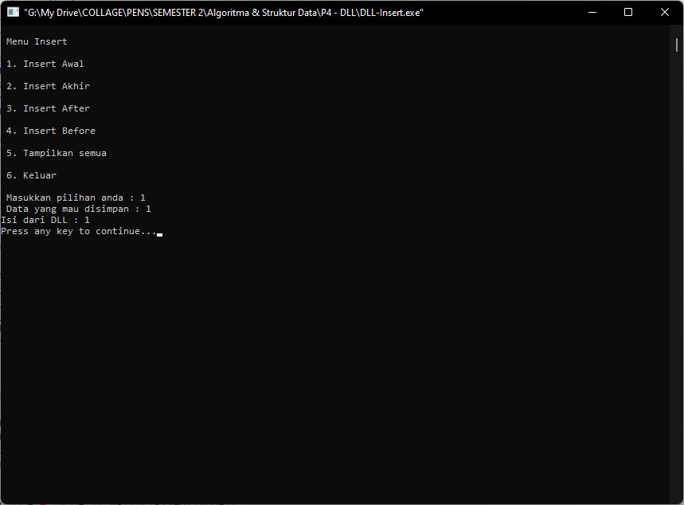

Insert Akhir

Source Code :

|  |
| --- |
| Node * insert_bottom(int num, Node *head) {  Node *current_node = head;  Node *new_node;  while ( current_node != NULL && current_node->next != NULL) {  current_node = current_node->next;  }  new_node = (Node *) malloc(sizeof(Node));  new_node->data = num;  new_node->next= NULL;  if (current_node != NULL)  current_node->next = new_node;  else  head = new_node;  return head;  } |

Output:

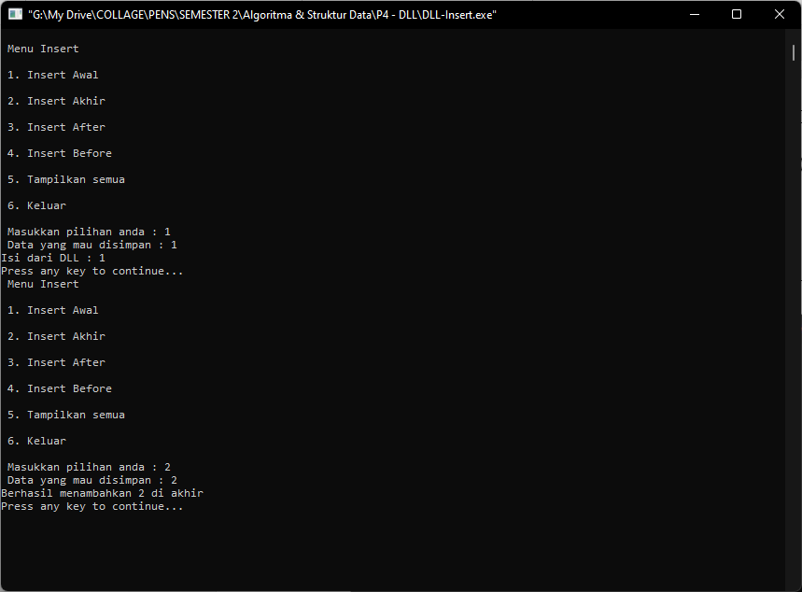

Insert After

Source code :

|  |
| --- |
| Node * insert_after(int num, int prev_num, Node *head) {  Node *current_node = head;  Node *new_node;  while ( current_node->data != prev_num) {  current_node = current_node->next;  }  new_node = (Node *) malloc(sizeof(Node));  new_node->data = num;  new_node->next= current_node->next;  current_node->next = new_node;  return head;  } |

Output :

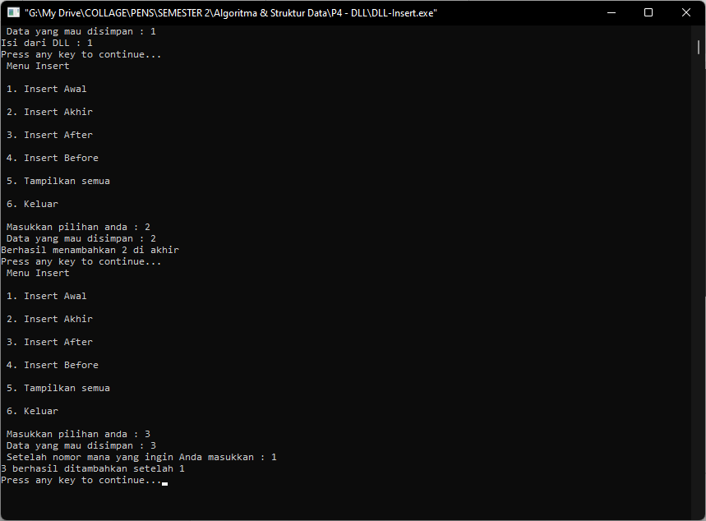

Insert Before

Source code :

|  |
| --- |
| Node * insert_before(int num, int next_num, Node *head) {  Node *current_node = head;  Node *new_node;  while ( current_node->next->data != next_num) {  current_node = current_node->next;  }  new_node = (Node *) malloc(sizeof(Node));  new_node->data = num;  new_node->next= current_node->next;  current_node->next = new_node;  return head;  } |

Output :

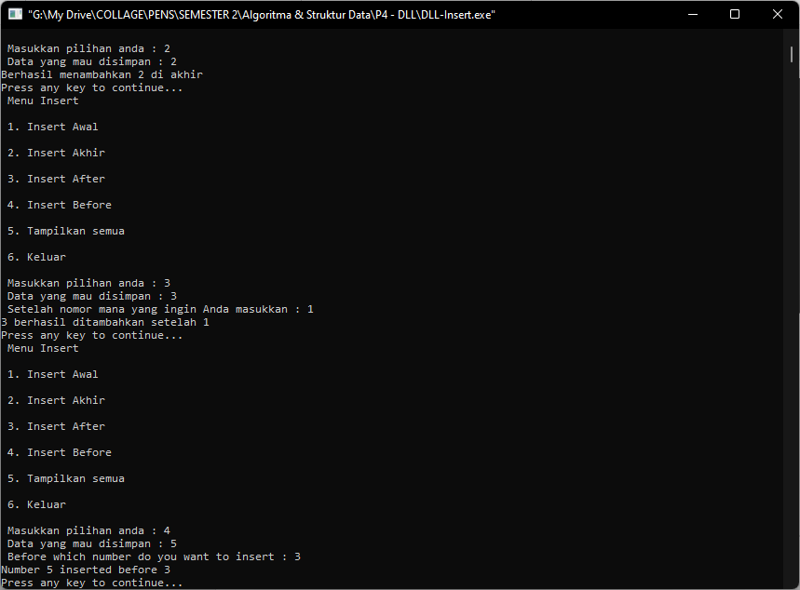

Data yang berhasil disimpan :

